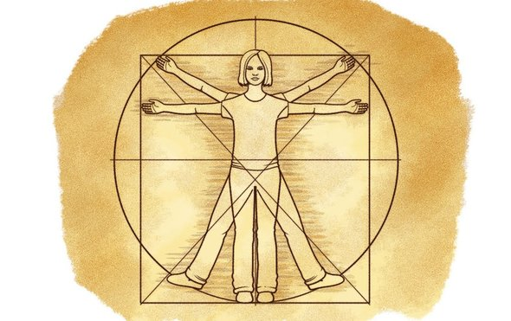
Research Question: Can you use your arm span to predict your height?
Skills: Hypothesis writing, collecting, organizing, analyzing and explaining data
Vocabulary:
Predict, relate, hypothesis, analyze, organize, quantities horizontally, ratio, avid, deviation, advantageous,
Introduction
Our bodies are amazing! They are full of mysteries and surprising facts such as this one: Did you know that you are about a centimeter taller in the morning, when you have just woken up after hours of lying down, than you are in the evening? You might never have noticed it. These interesting facts only reveal themselves when you look closely, measure and compare. That is what this activity is about: recording, comparing and discovering how the human body measures up!
Background
Did you know that human bodies come in all sizes and forms? When you start measuring them, however, you will find our bodies show surprising similarities—and even more surprisingly, we can express these with mathematical concepts. For one thing, our bodies are quite symmetrical. When you draw a vertical line down the center of a body, the left and right sides are almost mirror images of each other. Human bodies also show interesting ratios. Ratios compare two quantities, like the size of one part of the body to the size of another part, or to the size of the whole. An example of a human body ratio is a person's arm span—the distance from the middle fingertip of the left hand to that of the right hand when stretching out both arms horizontally—to their height. This ratio is approximately a one to one ratio, meaning that a person’s arm span is about equal to their height. There are many more human body ratios; some are independent of age, and others change as we grow from a baby to an adult. For example, the head to body ratio is a little more complex as it changes from a ratio of about one to four for a small child to about one to eight for an adult. A five-year-old is likely to have a head to body ratio of about one to six.
Wondering who would be interested in these ratios? Artists are avid users of human body ratios, because it helps them draw realistic-looking figures. They are also used in the medical world; a sizable deviation from a human body ratio can indicate a body that does not develop according to expectations. In this science activity we will examine some human body ratios and, if you like, we can explore how they can help you draw more realistic-looking figures.
Hypothesis: If a student’s arm span is _______cm then their height will be ________________ because
____________________________________________________________________________________.
Materials: Measuring tape, ruler, meterstick, graph paper,
Procedures:
Step 1
Step 2
Data Results:
Data Table: Arm Span and Height Ratios
Student | Arm Span  (include units) | Height  (include units) | Arm Span to Height Ratio – Set up | Arm Span to Height Ratio
Exemplar | 150.0 cm | 149.5 cm | Arm Span = 150.0 cm  Height = 149.5 cm
Student 1
Student 2
Student 3
Student 4

Graph Data: Construct a well labeled line graph of Arm Span and Height that includes individual data for each member of your group.
Analysis and Conclusion: NEATLY and proudly, write your response using the Claim, Evidence, and Reasoning strategy that we have been practicing.
I. Claim: The data ________________ support the hypothesis.
(do, do not)
II. Evidence:
A. Cite exact data from the table and graph that show the data you collected are consistent with your claim.
You should include data to address how the ratio calculations for 3-4 different students compare.
Was there a significant difference between the arm span and heights for each student?
B. Sentence Stem: The data show that students with longer arm spans tended to have greater heights.
For example, student A had the longest arm span (______ cm) and tallest height (_____) .

III. Reasoning – Connect the evidence to your claim by using what you have read to explain how the data supports your claim.

