Name:_______________________________________ Period:_______ Date:____________
Grade 7 Informative Essay on Phase Changes
Prompt: In a well-developed paragraph, compare and contrast the three states of matter by giving supporting evidence from the two essays.

Matter can change from one phase (state) to another when heat is added or removed. When this occurs, the appearance of the matter may change drastically. However, the chemical composition remains the same. To visualize the process of a phase change from a solid to a liquid, pretend you held hands with someone, and each of you started jumping around. The more violently you jumped, the more difficult keeping hold would be. If you jumped violently enough, keeping hold would be impossible. Something like this happens to the particles of a solid when it is heated. As heat is absorbed, the particles vibrate more and more violently. If enough heat is absorbed, the forces between the particles will no longer be able to hold them together. The solid melts into a liquid.
Freezing is exactly the opposite. The particles slow down more and more until they can be held tightly together. This can be demonstrated by using hot air from hair dryer with a 2-liter bottle filled with packing peanuts. When you turn the hair dryer on low and aim the air flow into the opening of the 2-liter bottle, the packing peanuts barely move. Without much heat the particles are barely moving. This represents particles in a solid.
When enough heat is added to a solid the particles begin to move more quickly and the substance melts into a liquid. When you turn the hair dryer on medium, the packing peanuts begin to move faster. When enough heat is added to the liquid the particles move so fast that the substance boils and the substance becomes a gas. Boiling is just a faster form of evaporation.
A glass of some liquid water, a solid stick of butter or cheese, and a balloon filled with helium all exist in different phases when they are at room temperature. Different substances exist as solids, liquids, and gases at specific temperatures. For example, ice is solid water at a temperature of 0 °C. Ice melts into liquid water when heat is added. When heat raises the temperature of the water to 100°C, the water boils, producing steam, which is a gas. These properties of water help to identify the physical property of the substance. Ice cream, wax, butter, chocolate, and cheese all melt at different temperatures. Each of these materials would also boil at different temperatures. Most pure substances, such as water and metals can be identified by their specific melting points and boiling points. These properties help to identify the substances. Show students the Melting and Boiling Points Table of Information.

What’s the Point? - Reading Notes

Most matter that we see everyday can be placed in one of three groups. The three groups are (1) solid, (2) liquid, or (3) gas. A rock and a piece of ice are solids. Water and milk are liquids. Air and water vapor are gases. All matter, whether a solid, liquid, or gas, is made up of extremely tiny particles called molecules which are always moving.

Solid, liquid, and gas are states of matter. Each state is a property of matter. The states of matter are different because of the way they change shape and volume. A solid does not easily change shape or volume. You can move a rock from one place to another. But the shape and volume of the rock do not change. It is hard to imagine that the molecules in a rock are moving, even if it is just a very little bit. In a solid the forces that hold the molecules near to one another are pretty strong. This is why the molecules don’t move very much and why solids don’t fall apart easily. When heat energy is added to ice, the individual molecules do move faster and water is formed. This is called melting.

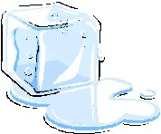
A liquid can change shape but it does not easily change volume. Pouring water from a tall, thin glass to a short, wide glass causes the water's shape to change but you still have the same amount of water. The volume does not change. In a liquid, the forces that hold the molecules near to one another are not as strong as in a solid. That is why the molecules in a liquid can move around so much and why liquids are so easy to splash around into different shapes and droplets. Water molecules slow down when heat energy is removed and ice is formed. This is called freezing. When heat energy is added, water molecules speed up and water vapor is formed. This is called evaporation.

A gas can easily change shape and volume. If you blow up a balloon, the air takes the shape of the balloon. The volume of the air changes, too. The air spreads out to inflate the balloon. In a gas, the molecules are free to move all over the place and they are very far apart. They zoom all around, bumping into each other and then bouncing off to zoom away in another direction. The forces that hold solids and liquids together have almost no effect in a gas. This is why the particles in a gas move around so much, so far, and so fast. When heat energy is removed from water vapor, the gas molecules slow down and water is formed. This is called condensation.

Molecules in each state of matter move in different ways. In a gas, the molecules move quickly. In a liquid, the molecules move slower. In a solid, the molecules move very slowly back and forth.
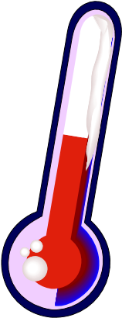
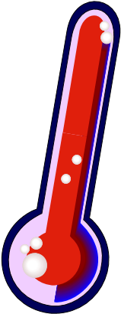
A change in matter that does not form different molecules is called a physical change. Ice, water, and water vapor are all made of water molecules. This means ice, water, and water vapor are the same kind of matter. Each state of water looks different because it has gone through a physical change. Heat can be removed or heat can be added to cause a change in state of matter.

