SRSD Science Prompt # 4
Grade 7
Elements, Compounds, and Mixtures

Prompt: 1. Read the article “Elements, Compounds, and Mixtures”.
2. Identify a, b, and c as an element, compound, or mixture below in your well-written response.
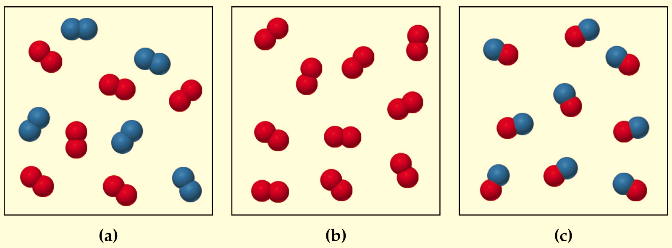
3. Use evidence in determining the element, compound, and mixture when describing them in your response.

Elements, Compounds, and Mixtures

One of the things we chemists like to do is to organize everything into categories. This makes our lives easier because it allows us to remember the properties of classes of things rather than to remember the specific and individual properties of everything we come across. When dealing with materials, we typically classify things as being either elements, compounds, or mixtures.
The World of Elements
Elements are defined as substances that cannot be chemically decomposed into simpler substances. To understand what this somewhat confusing definition means, let’s discuss an example.
Gold is an element, as are all of the substances on the periodic table. If you have a block of gold, you can do a lot of things to it—melt it, dent it, and so forth. One thing you can’t do, however, is break the gold atoms down into simpler materials. As an element, the gold atoms are, for our purposes, indestructible.
Chemical Compounds
Chemical compounds are two (different) or more elements that are chemically combined. Materials which consist of elements bonded to one another in defined proportions are called compounds. To understand this, let’s take the example of water, H₂O. When we talk about water, we’re always talking about H₂O. Water never has the formula H₄O or anything else—no matter what, it always has two atoms of hydrogen and one atom of oxygen. Because it always has the proportion of 2 H to 1 O, and because the hydrogen and oxygen atoms are chemically bonded to one another, water is a chemical compound.
Unlike an element, a compound can be broken down into simpler materials through the use of chemical reactions. For example, through a process known as electrolysis, water can be broken down into hydrogen gas (H₂) and oxygen gas (O₂).
Mixtures
Mixtures are materials that contain more than one type of element or compound. One example of a mixture is salt water—because it contains both water (H₂O) and salt (NaCl), it’s a mixture. Other mixtures you may have come across include salad, air we breathe, bag of different candies, and the soda.
Though there are a lot of different mixtures, we can further break down the classification of mixtures to include two different subcategories: homogeneous mixtures and heterogeneous mixtures. Let’s take a look at each:
- Homogeneous mixtures are mixtures in which the components are completely and evenly mixed with one another. An example of this is salt water. If you take a small portion of salt water from one side of a glass and another small portion of salt water from the other side of the glass, both will have identical ratios of salt to water.
- Heterogeneous mixtures are unevenly combined mixtures. If you take one sample of a heterogeneous mixture and another sample from a different part of the mixture, the two won’t be identical to one another. For example, water and oil do not mix evenly. The oil will float on top of the oil.
- Colloids: Somewhere between homogeneous and heterogeneous mixtures lie the colloids. Colloids are heterogeneous mixtures which appear completely uniform in composition, but really just have one type of particle suspended in another without having been dissolved.

Elements
- consists of only one kind of atom,
- cannot be broken down into a simpler type of matter by either physical or chemical means, and
- can exist as either atoms (e.g. argon) or molecules (e.g., nitrogen).
A molecule consists of two or more atoms of the same element, or different elements, that are chemically bound together. Note that the two nitrogen atoms which comprise a nitrogen molecule move as a unit.

Compounds
Note that a compound:
- consists of atoms of two or more different elements bound together,
- can be broken down into a simpler type of matter (elements) by chemical means (but not by physical means),
- has properties that are different from its component elements, and
- always contains the same ratio of its component atoms.

Mixtures
- consists of two or more different elements and/or compounds physically combined,
- can be separated into its components by physical means, and
- often retains many of the properties of its components.

Matter Flow Chart
