Industrial Revolution Task
Housing Images
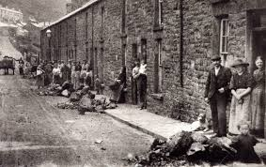

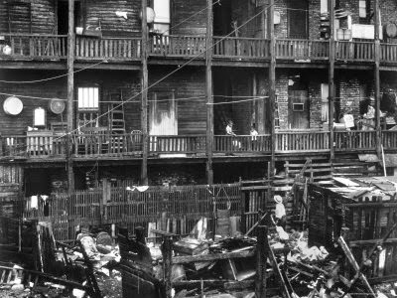
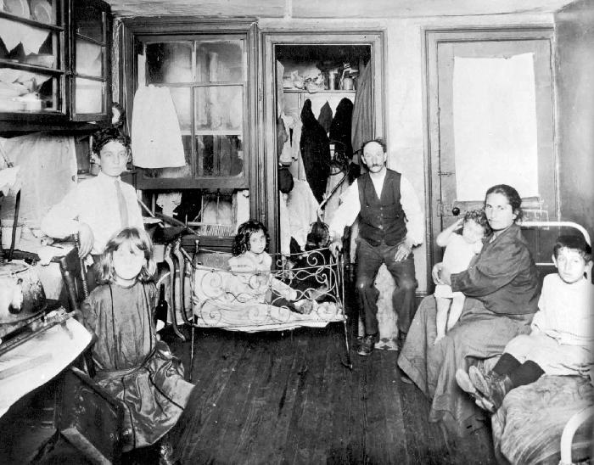

Primary Source Description of River Thames in London (1855)
“Observations on the Filth of the Thames”
SIR,
I traversed this day by steam-boat the space between London and Hangerford Bridges between half-past one and two o'clock; it was low water, and I think the tide must have been near the turn. The appearance and the smell of the water forced themselves at once on my attention. The whole of the river was an opaque pale brown fluid. . . . The smell was very bad, and common to the whole of the water; it was the same as that which now comes up from the gully-holes in the streets; the whole river was for the time a real sewer. Having just returned from out of the country air, I was, perhaps, more affected by it than others; but I do not think I could have gone on to Lambeth or Chelsea, and I was glad to enter the streets for an atmosphere which, except near the sink-holes, I found much sweeter than that on the river.
I have thought it a duty to record these facts, that they may be brought to the attention of those who exercise power or have responsibility in relation to the condition of our river; there is nothing figurative in the words I have employed, or any approach to exaggeration; they are the simple truth. . . . surely the river which flows for so many miles through London ought not to be allowed to become a fermenting sewer
Sincerely,
Professor Faraday

Primary Source: Elizabeth Bentley (1832)
Question: What were your hours of labour?
Answer: As a child I worked from five in the morning till nine at night.
Question: What time was allowed for meals?
Answer: We were allowed forty minutes at noon.
Question: Had you any time to get breakfast, or drinking?
Answer: No, we got it as we could.
Question: Did you have time to eat it?
Answer: No; we were obliged to leave it or to take it home, and when we did not take it, the overlooker took it, and gave it to the pigs.
Question: Suppose you flagged a little, or were late, what would they do?
Answer: Strap us [whip with a strap or belt].
Question: What work did you do?
Answer: A weigher in the card-room.
Question: How long did you work there?
Answer: From half-past five [in the morning], till eight at night.
Question: What is the carding-room like?
Answer: Dusty. You cannot see each other for dust.
Question: Did working in the card-room affect your health?
Answer: Yes; it was so dusty, the dust got up my lungs, and the work was so hard. I got so bad in health, that when I pulled the baskets down, I pulled my bones out of their places.
Question: You are considerably deformed in your person in consequence of this labour?
Answer: Yes, I am.
Question: At what time did it come on?
Answer: I was about thirteen years old when it began coming, and it has got worse since. When my mother died I had to look after myself.
Question: Where are you now?
Answer: In the poor house.
Question: You are utterly incapable of working in the factories?
Answer: Yes
Question: You were willing to have worked as long as you were able, from your earliest age?
Answer: Yes.
Question: And you supported your widowed mother as long as you could?
Answer: Yes.

Primary Source: Michael Crabtree (1832)
Question: What age are you?
Answer: Twenty-two.
Question: What is your occupation?
Answer: A blanket manufacturer.
Question: Have you ever been employed in a factory?
Answer: Yes.
Question: At what age did you first go to work in one?
Answer: Eight.
Question: How long did you continue in that occupation?
Answer: Four years.
Question: Will you state the hours of labour at the period when you first went to the factory, in ordinary times?
Answer: From 6 in the morning to 8 at night.
Question: Fourteen hours?
Answer: Yes.
Question: With what intervals for refreshment and rest?
Answer: An hour at noon.
Question: When trade was brisk what were your hours?
Answer: From 5 in the morning to 9 in the evening.
Question: Sixteen hours?
Answer: Yes.
Question: With what intervals at dinner?
Answer: An hour.
Question: How far did you live from the mill?
Answer: About two miles.
Question: Was there any time allowed for you to get your breakfast in the mill?
Answer: No.
Question: Did you take it before you left your home?
Answer: Generally.
Question: During those long hours of labour could you be punctual; how did you awake?
Answer: I seldom did awake spontaneously; I was most generally awoke or lifted out of bed, sometimes asleep, by my parents.
Question: Were you always in time?
Answer: No.
Question: What was the consequence if you had been too late?
Answer: I was most commonly beaten.
Question: Severely?
Answer: Very severely, I thought.
Question: In those mills is chastisement towards the latter part of the day going on perpetually?
Answer: Perpetually.
Question: So that you can hardly be in a mill without hearing constant crying?
Answer: Never an hour, I believe.
Question: Do you think that if the overlooker were naturally a humane person it would still be found necessary for him to beat the children, in order to keep up their attention and vigilance at the termination of those extraordinary days of labour?
Answer: Yes; the machine turns off a regular quantity of cardings, and of course, they must keep as regularly to their work the whole of the day; they must keep with the machine, and therefore however humane the slubber may be, as he must keep up with the machine or be found fault with, he spurs the children to keep up also by various means but that which he commonly resorts to is to strap them when they become drowsy.
Question: At the time when you were beaten for not keeping up with your work, were you anxious to have done it if you possibly could?
Answer: Yes; the dread of being beaten if we could not keep up with our work was a sufficient impulse to keep us to it if we could.
Question: When you got home at night after this labour, did you feel much fatigued?
Answer: Very much so.
Question: Had you any time to be with your parents, and to receive instruction from them?
Answer: No.
Question: What did you do?
Answer: All that we did when we got home was to get the little bit of supper that was provided for us and go to bed immediately. If the supper had not been ready directly, we should have gone to sleep while it was preparing.
Question: Did you not, as a child, feel it a very grievous hardship to be roused so soon in the morning?
Answer: I did.
Question: Were the rest of the children similarly circumstanced?
Answer: Yes, all of them; but they were not all of them so far from their work as I was.
Question: And if you had been too late you were under the apprehension of being cruelly beaten?
Answer: I generally was beaten when I happened to be too late; and when I got up in the morning the apprehension of that was so great, that I used to run, and cry all the way as I went to the mill.

Chadwick's Report on Sanitary Conditions
Edwin Chadwick (1803-1890) had taken an active part in the reform of the Poor Law and in factory legislation before he became secretary to a commission investigating sanitary conditions and means of improving them. The Commission's report, of which the summary is given below, is the third of the great reports of this epoch.

[Report...from the Poor Law Commissioners on an Inquiry into the Sanitary Conditions of the Labouring Population of Great Britain. London, 1842, pp. 369-372.]
After as careful an examination of the evidence collected as I have been enabled to make, I beg leave to recapitulate the chief conclusions which that evidence appears to me to establish.
First, as to the extent and operation of the evils wich are the subject of this inquiry:--
That the various forms of epidemic, endemic, and other disease caused, or aggravated, or propagated chiefly amongst the labouring classes by atmospheric impurities produced by decomposing animal and vegetable substances, by damp and filth, and close and overcrowded dwellings prevail amongst the population in every part of the kingdom, whether dwelling in separate houses, in rural villages, in small towns, in the larger towns--as they have been found to prevail in the lowest districts of the metropolis.
That such disease, wherever its attacks are frequent, is always found in connexion with the physical circumstances above specified, and that where those circumstances are removed by drainage, proper cleansing, better ventilation, and other means of diminishing atmospheric impurity, the frequency and intensity of such disease is abated; and where the removal of the noxious agencies appears to be complete, such disease almost entirely disappears.
The high prosperity in respect to employment and wages, and various and abundant food, have afforded to the labouring classes no exemptions from attacks of epidemic disease, which have been as frequent and as fatal in periods of commercial and manufacturing prosperity as in any others.
That the formation of all habits of cleanliness is obstructed by defective supplies of water.
That the annual loss of life from filth and bad ventilation are greater than the loss from death or wounds in any wars in which the country has been engaged in modern times.
That of the 43,000 cases of widowhood, and 112,000 cases of destitute orphanage relieved from the poor's rates in England and Wales alone, it appears that the greatest proportion of deaths of the heads of families occurred from the above specified and other removable causes; that their ages were under 45 years; that is to say, 13 years below the natural probabilities of life as shown by the experience of the whole population of Sweden.
That the public loss from the premature deaths of the heads of families is greater than can be represented by any enumeration of the pecuniary burdens consequent upon their sickness and death.
That, measuring the loss of working ability amongst large classes by the instances of gain, even from incomplete arrangements for the removal of noxious influences from places of work or from abodes, that this loss cannot be less than eight or ten years.
That the ravages of epidemics and other diseases do not diminish but tend to increase the pressure of population.
That in the districts where the mortality is greatest the births are not only sufficient to replace the numbers removed by death, but to add to the population.
That the younger population, bred up under noxious physical agencies, is inferior in physical organization and general health to a population preserved from the presence of such agencies.
That the population so exposed is less susceptible of moral influences, and the effects of education are more transient than with a healthy population.
That these adverse circumstances tend to produce an adult population short-lived, improvident, reckless, and intemperate, and with habitual avidity for sensual gratifications.
That these habits lead to the abandonment of all the conveniences and decencies of life, and especially lead to the overcrowding of their homes, which is destructive to the morality as well as the health of large classes of both sexes.
That defective town cleansing fosters habits of the most abject degradation and tends to the demoralization of large numbers of human beings, who subsist by means of what they find amidst the noxious filth accumulated in neglected streets and bye-places.
That the expenses of local public works are in general unequally and unfairly assessed, oppressively and uneconomically collected, by separate collections, wastefully expended in separate and inefficient operations by unskilled and practically irresponsible officers.
That the existing law for the protection of the public health and the constititional machinery for reclaiming its execution, such as the Courts Leet, have fallen into desuetude, and are in the state indicated by the prevalence of the evils they were intended to prevent.
Secondly. As to the means by which the present sanitary condition of the labouring classes may be improved:--
The primary and most important measures, and at the same time the most practicable, and within the recognized province of public administration, are drainage, the removal of all refuse of habitations, streets, and roads, and the improvement of the supplies of water.
That the chief obstacles to the immediate removal of decomposing refuse of towns and habitations have been the expense and annoyance of the hand labour and cartage requisite for the purpose.
That this expense may be reduced to one-twentieth or to one-thirtieth, or rendered inconsiderable, by the use of water and self-acting means of removal by improved and cheaper sewers and drains.
That refuse when thus held in suspension in water may be most cheaply and innoxiously conveyed to any distance out of towns, and also in the best form for productive use, and that the loss and injury by the pollution of natural streams may be avoided.
That for all these purposes, as well as for domestic use, better supplies of water are absolutely necessary.
That for successful and economical drainage the adoption of geological areas as the basis of operations is requisite.
That appropriate scientific arrangements for pulic drainage would afford important facilities for private land-drainage, which is important for the health as well as sustenance of the labouring classes.
That the expense of public drainage, of supplies of water laid on in houses, and of means of improved cleansing would be a pecuniary gain, by diminishing the existing charges attendant on sickness and premature mortality.
That for the protection of the labouring classes and of the ratepayers against inefficiency and waste in all new structural arrangements for the protection of the public health, and to ensure public confidence that the expenditure will be beneficial, securities should be taken that all new local public works are devised and conducted by responsible officers qualified by the possession of the science and skill of civil engineers.
That the oppressiveness and injustice of levies for the whole immediate outlay on such works upon persons who have only short interests in the benefits may be avoided by care in spreading the expense over periods coincident with the benefits.
That by appropriate arrangements, 10 or 15 per cent. on the ordinary outlay for drainage might be saved, which on an estimate of the expense of the necessary structural alterations of one-third only of the existing tenements would be a saving of one million and a half sterling, besides the reduction of the future expenses of management.
That for the prevention of the disease occasioned by defective ventilation and other causes of impurity in places of work and other places where large numbers are assembled, and for the general promotion of the means necessary to prevent disease, that it would be good economy to appoint a district medical officer independent of private practice, and with the securities of special qualifications and responsibilities to initiate sanitary measures and reclaim the execution of the law.
That by the combinations of all these arrangements, it is probable that the full ensurable period of life indicated by the Swedish tables; that is, an increase of 13 years at least, may be extended to the whole of the labouring classes.
That the attainment of these and the other collateral advantages of reducing existing charges and expenditure are within the power of the legislature, and are dependent mainly on the securities taken for the application of practical science, skill, and economy in the direction of local public works.
And that the removal of noxious physical circumstances, and the promotion of civic, household, and personal cleanliness, are necessary to the improvement of the moral condition of the population; for that sound morality and refinement in manners and health are not long found co-existent with filthy habits amongst any class of the community.

Prompt: The Industrial Revolution changed the way people lived. What were some of the positive changes? Where were some of the negative changes? Do you think the Industrial Revolution was more beneficial or harmful to society? Why?

