Text Source 1: Justinian--The Nika Rebellion
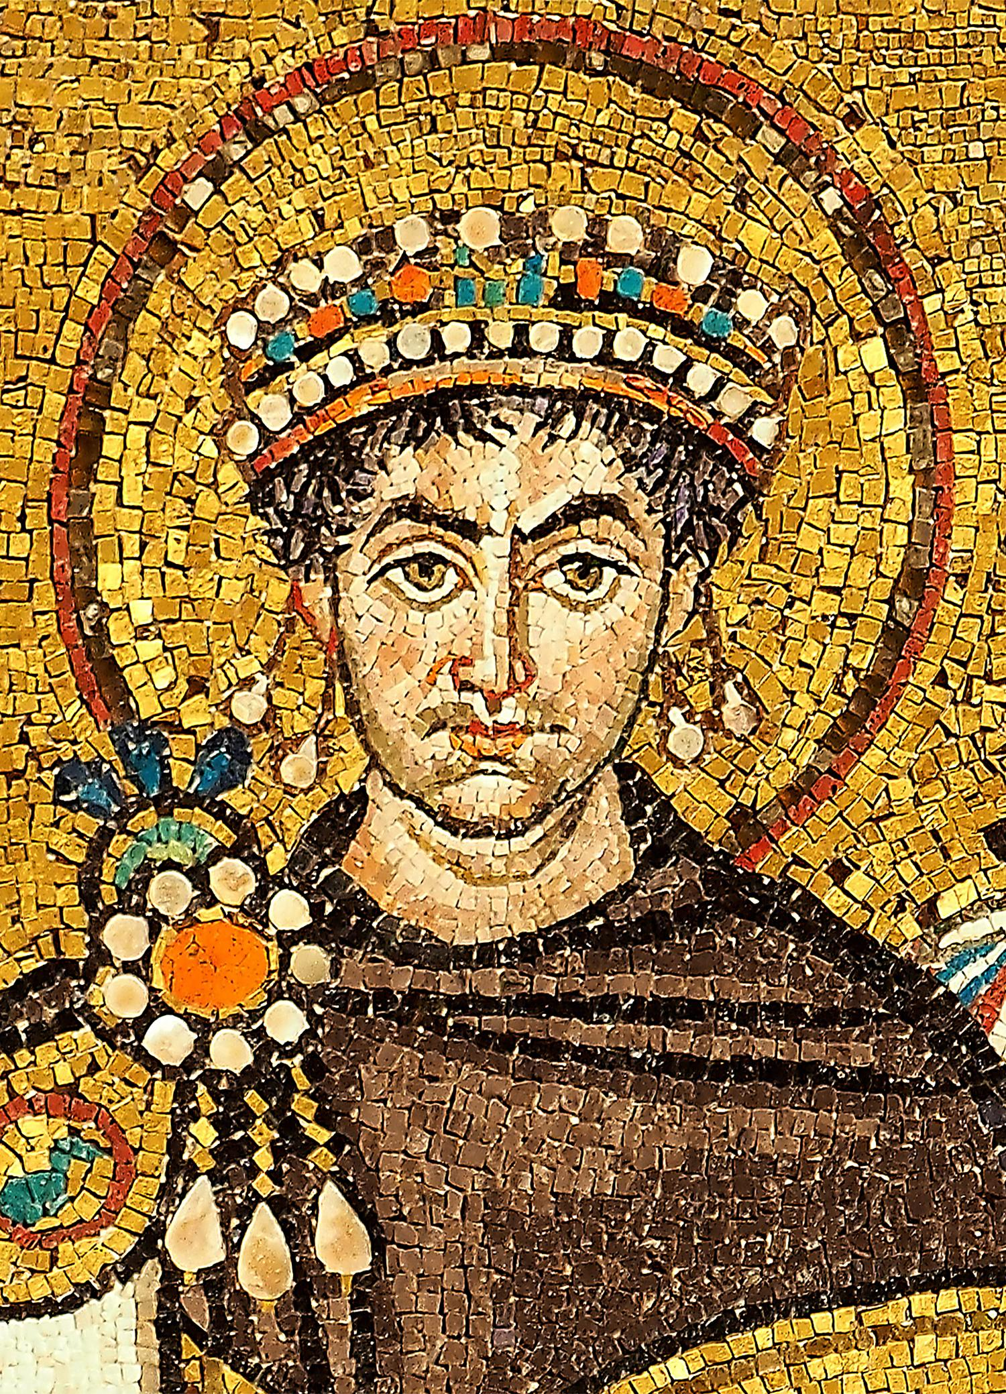
Perhaps the most important of all Byzantine Emperors was Justinian I, who ruled from 527 - 565. Justinian organized the code of laws for the Byzantine Empire, and regained much of the lands to the west that were lost to the Germanic Tribes. In 532 Justinian faced one of the most difficult crises of his reign, The Nika Rebellion.

Blues and Greens
The most popular entertainment in Constantinople was the chariot races in the Hippodrome - a copy of Rome’s Circus Maximus - which seated 80,000 fans. Two teams, the Blues and the Greens, raced there, as supporters clamored for their favorites from opposite sides of the bleachers. Over time the supporters of the teams were organized into groups much like modern-day political parties and became concerned with politics as well as horses. Clashes between Blues and Greens were common and sometimes turned into riots. Soon after Justinian was crowned, some members of both factions were out of control. They robbed and burned each other’s homes, kidnapped opponents, threatened judges, and murdered several people in church. Justinian was determined to stomp out these troublemakers. His first edict as emperor promised to punish the guilty and protect the helpless regardless of “color.” After another riot at the Hippodrome resulted in a number of deaths, he had seven ringleaders arrested and executed by hanging, which was common then.
The Rebellion
On January 13, 532 people made demands that the angry emperor refused to grant, so a riot began. While the crowd screamed “Nika” (“conquer”), the violence spilled over the walls of the racetrack. When troops moved into the city, a battle began. The rioters attacked a prison and released the inmates, a mob fought soldiers in the streets, and a fire that destroyed many buildings broke out. Justinian faced an angry mob. He fired several unpopular government officials and offered to let the rebels go unpunished if they would stay loyal. However, when he left, they chose a noble as their new emperor, and the violence continued.
Messengers were sent to bribe some of the rebel leaders, and the palace guard marched secretly to the Hippodrome. When the soldiers rushed into the arena, the mob ran. Within 24 hours 30,000 of the rioters lay lifeless in the racetrack and in the streets, murdered by Justinian’s army. The noble the rioters had crowned was beheaded and thrown into the sea, and the Hippodrome was closed for several years. Never again was Justinian’s power questioned.
Text Source 2: The Syrian Civil War
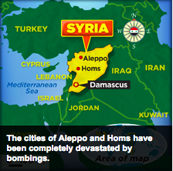
Fighting in Syria has been impacting the lives of people for five years. Since March 2011, this Middle Eastern nation has been caught in a deadly civil war. A civil war is an armed conflict between groups within a nation. Rebel forces in Syria are fighting the government of Bashar al-Assad. He is the dictator, or absolute ruler, of the country. Assad has denied Syrians many basic freedoms. The rebels want Assad to step down, but he refuses to do so.

HOW IT BEGAN
Syria's civil war began as part of the Arab Spring in 2011 with a series of protests against President Assad, whose family has maintained harsh control over the country for 44 years. Thousands of peaceful demonstrators took to the streets calling for Assad to resign. They wanted more freedoms as well as the right to vote for their government officials. But the government responded by violently attacking protesters and the Syrian President, Bashar al-Assad refused to step down. As Assad's security forces cracked down on demonstrators, armed rebels replaced peaceful protesters. These armed rebel groups trolled the streets, stealing food and harassing citizens. But Assad's forces were more brutal - using bombs, air strikes, and even chemical weapons to try to crush the rebellion. Neighborhoods were reduced to rubble. Many died in the attacks. The conflict soon became a full-blown civil war.

MILLIONS DISPLACED
Since the conflict in Syria began, more than 160,000 people have been killed, and 2.5 million refugees have fled to neighboring countries. Another 6.5 million have been displaced inside Syria. Refugees are people who are forced to leave their home countries, often because of war. Syria is especially dangerous for children. The children of Syria are now referred to as Syria's "lost generation." At least half of the refugees in Lebanon, Turkey, Iraq and other countries are children. Many no longer attend school. Entire Syrian cities, such as Aleppo and Homs, have been devastated by the regime’s bombings. This has left many Syrian citizens without homes. For the past few months, the city of Aleppo has been besieged by the regime of Bashar al-Assad. There is no food or medical aid getting in. “The crisis has become a disgraceful humanitarian calamity with suffering and displacement unparalleled in recent history,” says Antonio Guterres, the United Nations [U.N.) High Commissioner for Refugees.

THE INTERNATIONAL RESPONSE
On February 3, 2016 the United Nations issued a report titled, “Out of Sight, Out of Mind: Deaths in Detention in the Syrian Arab Republic.” It highlighted the Syrian government as having systematically arrested large numbers of people, denying them the right to a trial. The report suggested torture and execution were being used as tactics used by Assad’s regime. The international community has repeatedly called for a peaceful resolution to the conflict. Officials at the United Nations (U.N.) have tried to get the Assad government to negotiate with opposition leaders. But so far, these discussions have not led to an agreement.

A recent U.N. resolution demanded that both sides of the conflict at least allow aid packages to be delivered to Syrians in need. Despite this latest effort, the future of the nation continues to look grim.

Prompt: You’ve read the article Justinian and Theodora--the Nika Rebellion. And you’ve read the article The Syrian Civil War about Bashar Assad’s reaction to rebellion in Syria. Describe the ways in which Assad and Justinian responded to rebellions within their realms and the effect each dictator’s responses had? Be sure to respond to both parts of this question.

