Animal clones: Double trouble?
Cloning offers a way to reproduce genetically engineered animals from one parent rather than two. Explain the potential risks involved or advantages to society of cloning.
https://www.youtube.com/watch?v=YoEWYJHf0kU
From agriculture to medicine to law, animal cloning to create genetic twins could change our lives.
EMILY SOHN: JAN 27, 2004 — 12:00 AM EST
Have you ever had a hamburger so good you wished you could eat the same thing all over again? With the way that cloning research is going, you might someday get your wish. The United States government recently decided that it's safe to drink milk and eat meat that comes from cloned animals. The decision has inflamed arguments about human health, animal rights, and the difference between right and wrong.
Clones, like identical twins, are exact genetic copies of each other. The difference is that twins turn up without scientists' being involved and are born at the same time. Clones are created in the lab and can be born years apart. Already, scientists have cloned 11 kinds of animals, including sheep, cows, pigs, mice, and horses.
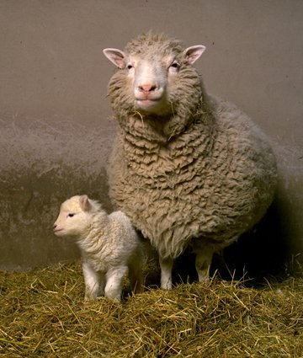
Dolly the sheep was the first mammal to be cloned from the DNA of an adult. Here she is with her first-born lamb, Bonnie.
As researchers continue to refine their techniques and clone even more animals, some people are worried. So far, cloned animals haven't fared well, critics say. Few cloning attempts are successful. The animals that do survive tend to die young.
How cloning works
To understand how cloning works, it helps to know how animals normally reproduce. All animals, including people, have a set of structures in each cell called chromosomes. Chromosomes contain genes. Genes are made of molecules known as DNA. DNA holds all the information necessary to keep cells and the body working. Humans have 23 pairs of chromosomes. Cows have 30 pairs. Other types of animals may have different numbers of pairs.
When two animals mate, each offspring gets one set of chromosomes from its mother and one from its father. The particular combination of genes that you happen to get determines a lot of things about you, such as the color of your eyes, whether you're allergic to pollen, and whether you're a boy or a girl. Parents have no control over which genes they give to their kids. That's why brothers and sisters can be so different from one another, even if they have the same mom and dad. Only identical twins are born with exactly the same combination of genes. The goal of cloning is to take control of the reproductive process. "You are taking out all the randomness," says reproductive physiologist Mark Westhusin, "by selecting a specific combination of genes to get what you want."
That's appealing to people who breed horses, dogs, or other animals for competition. It would be nice to preserve the combination of genes that make a horse fast, for instance, or a dog's coat especially curly. It might also be possible to use cloning to save endangered animals if there are too few of them to reproduce well on their own.
Farmers also have an interest in cloning. The average milk cow produces 17,000 pounds of milk a year, says Westhusin, who works at Texas A&M University in College Station. Every once in a while, a cow is born that can naturally produce 45,000 pounds of milk a year or more. If scientists could clone those exceptional cows, fewer cows would be needed to make milk. Cloning could save farmers money in other ways, too. Livestock are particularly vulnerable to certain diseases, including one called brucellosis. Some animals, though, have genes that make them naturally resistant to brucellosis. Cloning those animals could produce a whole herd of disease-free animals, saving farmers millions of dollars in lost meat.
With an endless supply of healthy, fast-growing animals, we might worry less about getting sick ourselves. Farmers wouldn't have to pump their animals full of antibiotics, which get into our meat and, some people think, make us unable to respond to those antibiotics when we become ill. Perhaps we could also protect ourselves against diseases that jump from animals to people, such as mad cow disease.
Kinks in the process
First, though, there are plenty of kinks still to be worked out. Cloning is a delicate procedure, and lots can go wrong along the way. "It's really quite remarkable that it works at all," Westhusin says. "There are lots of ways we know it doesn't work. The more difficult question is to figure out how sometimes it does." Westhusin is one of many researchers working hard to answer that question. His experiments focus mostly on goats, sheep, cattle, and some exotic animals, such as white-tailed deer and bighorn sheep.
To clone an animal, such as a cow, he starts by removing the chromosomes from a regular cow's egg. He replaces them with chromosomes taken from a skin cell belonging to another adult cow. Ordinarily, half the chromosomes in an egg would have come from the mother and half from the father. The resulting combination of genes would be entirely up to chance. With cloning, all of the chromosomes come from just one animal, so there's no chance involved. An animal and its clone have exactly the same genes.
When the egg starts dividing into an embryo, Westhusin puts it into a surrogate mother cow. The mother doesn't have to be the same cow that provided the skin cell. It just provides the womb for the clone to develop. If everything works just right, a calf is born, looking and acting just like a normal calf. More often than not, however, things don't work out quite right. It may take 100 tries to get one embryo to develop inside the mother, Westhusin says.
Dying young
Even if they make it to birth, cloned animals often seem doomed from the start. For reasons scientists don't yet understand, cloned baby animals often resemble animals born prematurely. Their lungs aren't fully developed, or their hearts don't work quite right, or their livers are full of fat, among other problems. As they age, some clones grow hugely overweight and bloated. Many cloned animals die at an earlier age than normal. Dolly the sheep, the first cloned mammal, died after only 6 years from a lung disease rare for sheep of her age. Most sheep live twice that long.
The problem, Westhusin thinks, is in the genes. Even though a skin cell has the same chromosomes as every other cell in the body, certain genes get turned on or off when a cell becomes specialized during development. That's what makes a brain cell different from a bone cell different from a skin cell. Scientists haven't yet figured out how to completely reprogram an adult cell's genes to recreate an entire animal.
Yesterday, they were acting like skin cells," Westhusin says. "Today, you're asking them to activate all their genes and start life all over again. You're asking them to turn genes on that normally wouldn't be turned on." There's a lot to be learned from these complications. "Studying what goes wrong," Westhusin says, "can give us clues and keys to what happens in nature. It's a model of development that shows how genes are reprogrammed."
Such complications also suggest why it might not be a good idea to clone a beloved pet. Even if a clone is nearly genetically identical to the original, it will still grow up with its own personality and behavior. Because of differences in diet before birth and as it grows up, it could end up a different size and have a different pattern of coat color. There's really no way to get a favorite pet back through cloning.
Clone chops
Even though cloning technology is far from perfect, milk and meat from cloned animals should be safe, Westhusin says. And the U.S. government agrees.
"There's no reason to believe, based on how clones are produced, that there are any food safety issues involved," Westhusin says. Cloned food products might appear on supermarket shelves in the near future.

'Designer babies' debate should start, scientists say
By James GallagherHealth editor, BBC News website
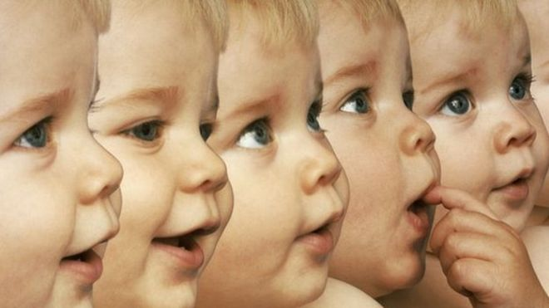
Rapid progress in genetics is making "designer babies" more likely and society needs to be prepared.
Dr Tony Perry, a pioneer in cloning, has announced precise DNA editing at the moment of conception in mice. He said huge advances in the past two years meant "designer babies" were no longer HG Wells territory. Other leading scientists and bioethicists argue it is time for a serious public debate on the issue.
Designer babies - genetically modified for beauty, intelligence or to be free of disease - have long been a topic of science fiction. Dr Perry, who was part of the teams to clone the first mice and pigs, said the prospect was still fiction, but science was rapidly catching up to make elements of it possible. In the journal Scientific Reports, he details precisely editing the genome of mice at the point DNA from the sperm and egg come together. Dr Perry, who is based at the University of Bath, told the BBC: "We used a pair of molecular scissors and a molecular sat-nav that tells the scissors where to cut.
"It is approaching 100% efficiency already, it's a case of 'you shoot you score'."
It is the latest development of "Crispr technology" - which is a more precise way of editing DNA than anything that has come before.
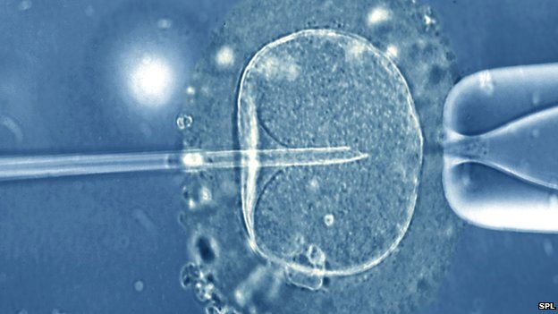
It was named one of the top breakthroughs in 2013, hailed as the start of a new era of genetics and is being used in a wide-range of experiments in thousands of laboratories. As well simply cutting the DNA to make mutations, as the Bath team have done, it is also possible to use the technology to insert new pieces of genetic code at the site of the cut. It has reopened questions about genetically modifying people.
Prof Perry added: "On the human side, one has to be very cautious. "There are heritable diseases coded by mutations in DNA and some people could say, 'I don't want my children to have these mutations.'"
This includes conditions such as cystic fibrosis and genes that increase the risk of cancer.
"There's much speculation here, but it's not completely fanciful, this is not HG Wells, you can imagine people doing this soon [in animals].
"At that time the HFEA [the UK's fertility regulator] will need to be prepared because they're going to have to deal with this issue."
He said science existed as part of a wider community and that it was up to society as a whole to begin assessing the implications and decide what is acceptable.

Prof Robin Lovell-Badge, from the UK Medical Research Council, has been influential in the debate around making babies from three people and uses the Crispr technology in his own lab. There needs to be a debate... and some rational thought rather than knee-jerk reactions that, 'No you can't possibly do that'.
He said testing embryos for disease during IVF would be the best way of preventing diseases being passed down through the generations. However, he could see such potential uses of "germ-line therapies" for men left infertile by damaging mutations. While they can have children through IVF, any sons would still have the mutations and would in turn need IVF. Genetic modification could fix that. It would also be useful in circumstances when all embryos would carry the undesirable, risky genes. Prof Lovell-Badge told the BBC News website: "Obviously in the UK, this is not allowed and there would have to be a change in regulations, which I suspect would have enormous problems.
"There has been a blanket ban on germ-line therapy, so there needs to be a debate about that and some rational thought rather than knee-jerk reactions that, 'No you can't possibly do that.'"
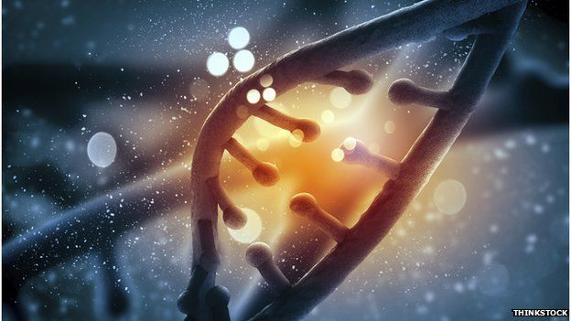
Such a debate would also have to move beyond therapies into the field of babies designed to have desirable traits. Some alternations would only require small changes to DNA, such as some changes to eye colour or to make a child HIV-resistant. The respected Nuffield Council on Bioethics is understood to be considering a report on the issue.
Its verdict in 2012 that it was ethical to create babies from three people formed a core part of the public debate on the issue. At the time it said a much wider debate on germ-line therapy was still needed.
Its director, Hugh Whittall, told the BBC: "I think this is a challenge, for all of us, we should get onto looking at this fairly rapidly now." He said the field raised questions of social justice around techniques available only to the rich and what constituted identity as well as "issues of governance and regulation".
Dr David King, from the campaign group Human Genetics Alert, echoed calls for the public to engage with the issue. He said: "I think it's pretty inevitable that we'll get to a point where it's scientifically possible, certainly these new techniques of genome editing have made something look much more feasible than it did five years ago.
"But that does not mean to say it's inevitably the way we have to go as a society."
This is still a matter of science fiction and there is a huge amount of research - particularly on unwanted mutations, efficiency and safety - that needs to be done before any attempt of humans would even be considered. A spokesman for the UK's Human Fertilisation and Embryology Authority said: "We keep a watchful eye on scientific developments of this kind and welcome discussions about future possible developments."
He said it "should be remembered that germ-line modification of nuclear DNA remains illegal in the UK" and that new legislation would be needed from Parliament "with all the open and public debate that would entail" for there to be any change in the law.

