Me, myself and i(Phone

Teenagers are growing more anxious and depressed.
Could they hold the culprit in their hands?
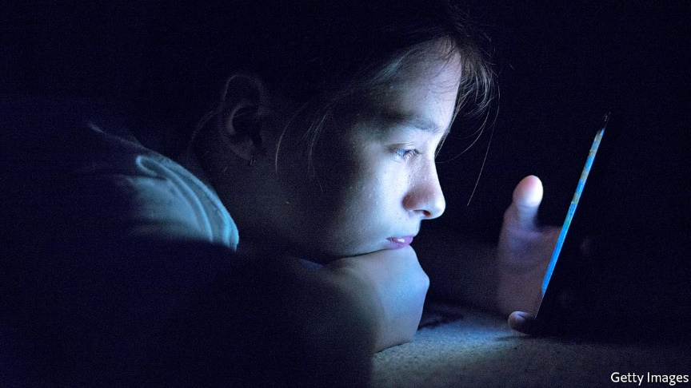
Nov 23rd 2017| LOS ANGELES
THE final bell rings at a high school in downtown Los Angeles, and nearly every pupil spilling onto the pavement either clutches a smartphone or studies a screen, head bowed. A group of boys strolls down the street laughing at a YouTube video, while a girl waiting for her lift home catches up with the Kardashian sisters on Instagram. Since 2007, when Apple released the first iPhone, such scenes have become the norm in America. The Pew Research Centre found that three-quarters of teens have access to a smartphone. According to one Facebook executive, millennials look at their phones on average more than 150 times a day. At the same time, teens have never reported higher rates of unhappiness.
A new study cites a possible factor in current widespread teenage melancholy—the many hours young people spend staring at their phone screens. That might be having serious effects, especially on young girls, according to the study’s author, Jean Twenge, a psychology professor at San Diego State University and author of “iGen: Why Today’s Super-Connected Kids Are Growing Up Less Rebellious, More Tolerant, Less Happy”.
By scrutinizing national surveys, with data collected from over 500,000 American teenagers, Ms Twenge found that adolescents who spent more time on new media—using Snapchat, Facebook, or Instagram on a smartphone, for instance—were more likely to agree with remarks such as: “The future often seems hopeless,” or “I feel that I can’t do anything right.” Those who used screens less, spending time playing sport, doing homework, or socializing with friends in person, were less likely to report mental troubles.
As Ms Twenge herself concedes, the study does not prove causality. It is possible that another force is behind the increased diagnosis of depression among adolescents, and that sad teenagers are more likely than their happy peers to seek refuge in their phones. But a growing body of scientific evidence supports the idea that social media can inspire malaise. One study published in 2016 asked a randomly selected group of adults to quit Facebook for a week; a control group continued browsing the site as usual. Those who gave up Facebook reported feeling less depressed at the end of the week than those who continued using it. Another experiment published in 2013 found that the more participants used Facebook, the gloomier they felt about their lives. Additionally, it showed that feeling blue did not lead people to increase their Facebook use.
Not all studies are so damning. Past research suggests that social-networking sites can promote happiness if used to engage directly with other users, rather than just to covet glossy photos of someone else’s exotic holiday or lavish wedding. This distinction is a reminder that social media is what users bring to it—their attitudes shape their experiences, both on and offline. “It’s pretty easy to romanticize someone’s life based on their Snapchat or Instagram,” reflects Sarah, a junior at high school in Los Angeles. “I try to remind myself that it’s filtered. People only post what they want you to see, so it can seem like their life is better than yours.” Nicole, another junior, agrees. But when asked if she has ever considered deleting her social-media accounts, she looks perplexed. “No. I would feel lost.”

Stop Freaking Out About Cell Phones

By Dr. Eric Swanson, Ph.D., Associate Professor of Nuclear Physics at the University of Pittsburg, published in Pittsburgh Post-Gazette on Aug 3, 2008

X-rays and UV rays carry enough energy that they can physically rearrange DNA structure inside our bodies (and that ain't good!). Visible light is not dangerous because it does not have enough energy to damage DNA...
What about cell phones? They typically broadcast between 800 Mhz and 2.1 GHz, which corresponds to an energy that is one million times less than visible light...
The only effect of such low-energy radiation is a tiny amount of heating of the ear and brain matter - about one one-thousandth as much as the brain heating caused by wearing a hat...
The nature of light and of our bodies suggest that cell phone radiation cannot cause cancer, no matter how much is present. Similarly, radio waves, TV transmissions, microwaves and the radiation from power lines are all too feeble to cause DNA damage, and, hence, cancer.
Tell your friends -- feel free to call them!

Prompt: Analyze how cell phone use issues are portrayed in these texts. Cite evidence from both texts.
Short write: Analyze one way in which a cell phone use issue is portrayed in this text. Cite evidence from either one or both texts.

