Name: _________________________________________________ Period:_____ Date: _________________
Cut and Grow – Elements, Compounds, and Mixtures
Word | Definition
Elements | An element is the simplest form of matter in that it cannot be further broken down using any chemical means. Elements are pure substances.
Compounds | A compound is a molecule made of atoms from different elements. All compounds are molecules, but not all molecules are compounds. Hydrogen gas (H₂) is a molecule, but not a compound because it is made of only one element. Water (H₂O) can be called a molecule or a compound because it is made of hydrogen (H) and oxygen (O) atoms. A compound is a substance formed when two (different) or more chemical elements are chemically bonded together.
Mixtures | A mixture is made when two or more substances are physically combined, but they are not combined chemically.  General properties of a mixture:  - The components of a mixture can be easily separated  - The components each keep their original properties  - The proportion of the components is variable  Types of Mixtures  There are two main categories of mixtures: homogeneous mixtures and heterogeneous mixtures. In a homogenous mixture all the substances are evenly distributed throughout the mixture (salt water, air, blood). In a heterogeneous mixture the substances are not evenly distributed (chocolate chip cookies, pizza, rocks)  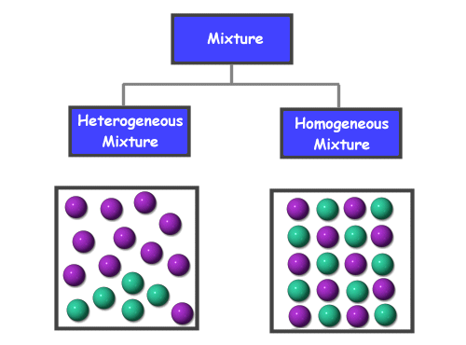  Within the categories of homogeneous and heterogeneous mixtures there are more specific types of mixtures including solutions, alloys, suspensions, and colloids.

Writing prompt: Your job as a chemist is to reorganize the chemical stockroom. You are going to separate the chemicals into groups of elements, compounds, and mixtures. Use your Vocabulary Activity Graphic Organizer – Elements, Compounds, and Mixtures to help you with writing the Cut and Grow story.

