Obama Jobs Speeches Mapped Out

Exemplar A Exemplar B
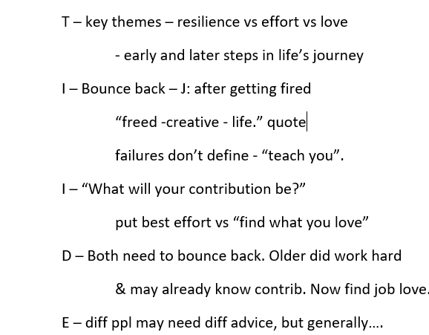
T: Context: 2 spchs, O-DC, J-Stan, shape futures
TS: Both – overcoming failure, but O-hard work for unproven kids vs J-love what you do (grads)

I: O - work hard, not quitters, don’t let down
D: O worked hard after failing (risk: his life ex could give idea that you can fail all along, then still succeed, so O is approp to advise them to work hard

I: J – do love & don’t settle (2x), “only way” love
D: J lived this – kept w/his job even when world turned against him. But - overlooks hard work & sticking w/it even when don’t love all work. OK for grads

E – 2 spchs w/one goal – futures. Hard work safer bet – more happiness in hard work

